**Twilio** Code for Recovery

**53JT3HGXM4WH2E8FES63VVM7**

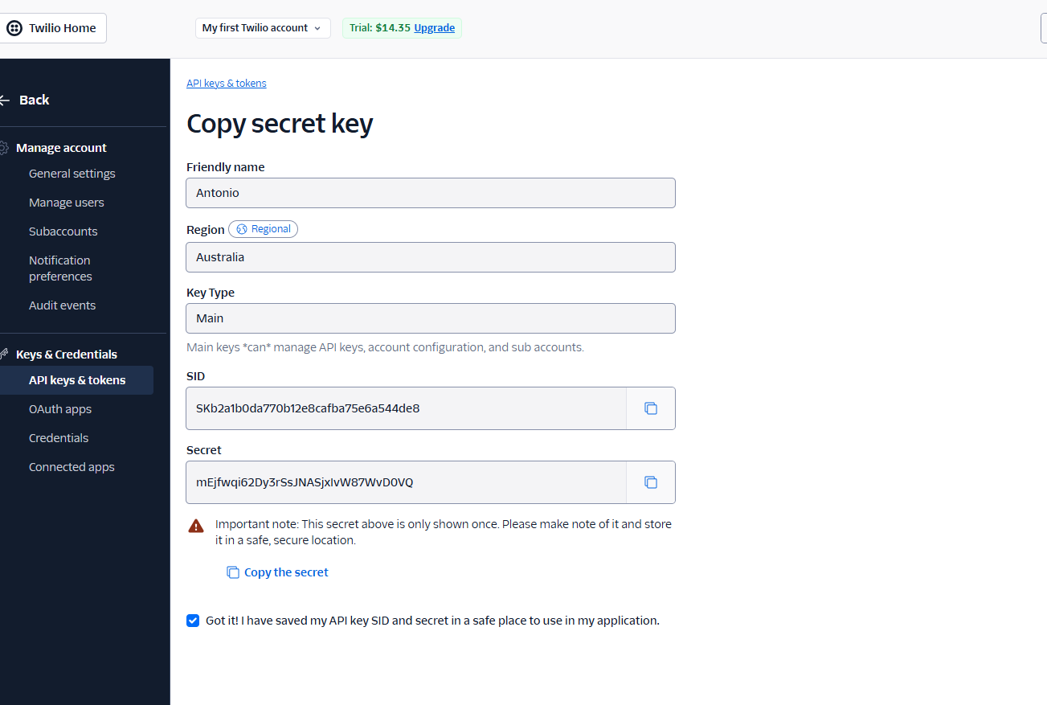

**Ph: Number : 03 41598933**

**Webhook URL:**

[**https://webhooks.twilio.com/v1/Accounts/AC7bb9e05a9ce20315b493d9d84c0c4fc3/Flows/FW9f2b020f7ee0976f221c7d4a6cae5b80**](https://webhooks.twilio.com/v1/Accounts/AC7bb9e05a9ce20315b493d9d84c0c4fc3/Flows/FW9f2b020f7ee0976f221c7d4a6cae5b80)

**TXT String in Squarespace:**

**facebook-domain-verification=qaozr680d93pz57toozxokwld4v4sr**